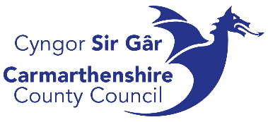
Briefing for Secondary Schools
‘Do-it-yourself’ self-tattooing and piercing
Carmarthenshire County Council and Public Health Wales are aware of a growing trend for ‘Do-it-yourself’ (DIY) self-tattooing and piercing in young people. This is partly due to the availability of self-tattoo and piercing kits online e.g. ‘Stick and Poke’, and an emerging trend of ‘Do It Yourself’ videos on the social media network TikTok as well as YouTube.
Any tattooing or piercing can carry some risk of harm, including skin infections and infections of the blood such as Hepatitis B, Hepatitis C and HIV. These health risks are much greater when unlicensed or DIY self-tattooing and piercing takes place. This is because good hygiene practices – such as not sharing needles and equipment that are contaminated with body fluids – are not followed.
Protecting young people from the harms of DIY self-tattooing and piercing is our priority. Therefore, we ask any young person that has had a DIY self-tattoo or piercing – whether using a kit or not – to come forward and seek confidential medical advice and treatment.
The local GP, Minor Injuries Unit or Accident and Emergency department can advise if treatment is required. This may include a vaccination to reduce the risk of infections and a blood test.
Giving a person a tattoo when they are younger than 18, even if the person giving the tattoo is also younger than 18 or if a parent/ guardian has agreed for the tattoo to be done, is illegal.

