Hi everyone, here is a newsletter outlining some information and activities you can do to help you to plan for when you leave school. I will be ringing you all in the next couple of weeks to see how you are getting on and to see if any of the links have helped you.
Contact me : bethan.rees@careerswales.gov.wales
07976 941863

Year 11  Task! | Have you got a bank account?  Something to think about doing is to open a bank account if you haven’t got one. In most cases this can be done online.  You will need one if you are:-  Eligible for EMA (education maintenance allowance)  Want a part or full time job  Applying for apprenticeships or traineeships
Year 10 Task! | Will you also think about employers you would like us to visit or come into school to see us & email & email me bethan.rees@careerswales.gov.wales with any ideas you have. We had some great visits this year & I am keen to keep them going!!  This will really help in getting everything organised for our time together next year!
Some interesting information on a career in construction can be found her
https://www.goconstruct.org/learn-about-construction/find-the-role-for-you/careers-a-to-z/

Its not something many of us have spoken about but plenty of interesting information about life in the Army here
https://apply.army.mod.uk/how-to-join/joining-process/virtual-acc

Buzz Quiz

Take the quiz to find out your personality type and what jobs might suit you. It’s quick, easy & fun, get the rest of the house to do one to see how alike or different you all are.

Click Here: https://careerswales.gov.wales/buzzquiz
Job Matching Quiz
Take the quiz to see the jobs that are linked to your skills & abilities Match your skills and interests to over 700 job titles and generate a personal job match! It will even show you the reasons why each job is a match for you!
Click Here: https://careerswales.gov.wales/plan-your-career/job-matching-quiz
Career Check 2020 | Career Check  Year 10’s if you could complete this for me it would really help us with our planning for leaving next year – yes you are leaving school for ever next year so let’s get a head start.  Click Here: https://www.smartsurvey.co.uk/s/CTFPO/
Curriculum Vita (C.V. Latin for "course of life")

You can click here: https://careerswales.gov.wales/getting-a-job/build-a-cv

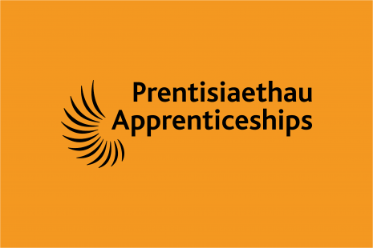 | Earn a wage while you gain qualifications. Be an apprentice!  For more information & the latest vacancies you need to check out the careers website, despite the lock down, employers are recruiting for when we all get back to normal  Click Here: https://careerswales.gov.wales/apprenticeships/what-is-an-apprenticeship
YEAR 10 | Have you?, Can You?, Make some notes?  - Completed Career Check https://www.smartsurvey.co.uk/s/CTFPO/  - Thought about a work placement for year 11?  - Thought about your year 11 timetable?  - Thought about leaving school next year?
YEAR 11 | Have you?, Can You?, Make some notes?  - Applied to college?  - Completed a CV?  - Registered to Careers Wales https://careerswales.gov.wales/  - Spoken to me about traineeships

bethan.rees@careerswales.gov.wales
07976 941 863

