COVID-19 Resources
20th March 2020

Date | Document | Description
11/03/2020 | https://www.bbc.co.uk/newsround/51698180 | BBC News  Good, accessible resources
12/03/2020 | https://www.bbc.co.uk/news/health-51048366 | BBC News  Coronavirus symptoms: What are they and how do I protect myself?
12/03/2020 | https://www.bbc.co.uk/news/health-51711227 | BBC News  Easy Steps: How to Stay Safe
12/03/2020 | https://www.bbc.co.uk/news/explainers-51632801 | BBC News  Coronavirus: How is the UK planning for an outbreak?
12/03/2020 | https://www.bbc.co.uk/news/business-51615412 | BBC News  Coronavirus: What are your travel rights?
13/03/2020 | - 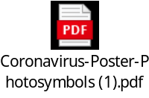  - 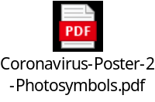  - 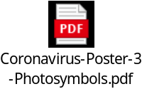 | Photosymbols posters on the following topic areas:  - Coronavirus: how to stay safe  - Coronavirus and Health Issues  - Coronavirus: what if you get ill?
13/03/2020 | https://www.bbc.co.uk/news/uk-51506729 | BBC News  Coronavirus: Should I self-isolate and how do I do it?
13/03/2020 | https://www.bbc.co.uk/news/world-51735367 | BBC News  Coronavirus: The fake health advice you should ignore
13/03/2020 | https://www.bbc.co.uk/news/av/health-51637561/coronavirus-watch-how-germs-spread | BBC News  Guide to Washing Hands Accurately
16/03/2020 | 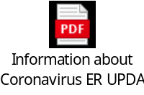 | Photosymbols  Information about Coronavirus
16/03/2020 | https://www.bbc.co.uk/news/health-51873799 | BBC News  Coronavirus: How to protect your mental health
17/03/2020 | 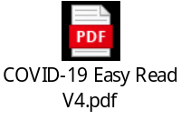 | Public Health Wales  Easy Read Information on COVID-19
18/03/2020 | 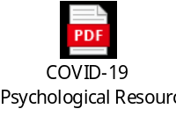 | Cardiff & Vale Child Health Psychology  Psychological Support for Children Coping with COVID-19
18/03/2020 | 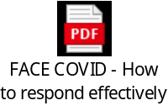 | ‘FACE COVID’  How to respond effectively to the Corona crisis  by Dr Russ Harris, author of The Happiness Trap
19/03/2020 | 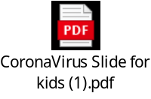 | Corona Virus slide for Kids
19/03/2020 | 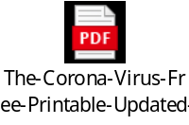 | The Autism Educator  The Corona Virus Free Printable Updated
19/03/2020 | 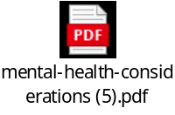 | WHO  Mental Health Considerations during COVID-19 Outbreak

